# **Lab 5**

Author: Qadeer Hussain

Student ID: C00270632

Table of Contents

**Lab 5** 1

**Traffic Shifting** 2

**Apply weight-based routing** 2

**Clean Up** 2

**Request Routing** 2

**Route to version 1** 2

**Route based on user identity** 3

**Fault Injection** 3

**Before you begin** 3

**Injecting an HTTP delay fault** 4

**Injecting an HTTP abort fault** 4

**Clean Up** 4

**Circuit Breaking** 4

**Before you begin** 4

**Configuring the circuit breaker** 5

**Adding a client** 5

**Tripping the circuit breaker** 5

**Clean Up** 7

## **Traffic Shifting**

### **Apply weight-based routing**

### **Clean Up**



## **Request Routing**

### **Route to version 1**



### **Route based on user identity**



## **Fault Injection**

### **Before you begin**

### **Injecting an HTTP delay fault**

### **Injecting an HTTP abort fault**

### **Clean Up**



## **Circuit Breaking**

### **Before you begin**

### **Configuring the circuit breaker**

### **Adding a client**

### **Tripping the circuit breaker**

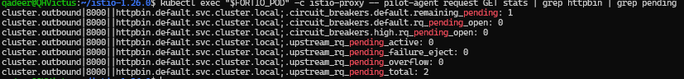

### **Clean Up**

